**VIRTUAL COMMUNITY DEVELOPMENT**

**Introduction**

It’s a Virtual Community Development project designed by Soumyak Kumar Bhoi. Here I used the concept of HTML, CSS, JAVASCRIPT, PHP and MySQL concept. It’s a virtual program developed for the people of the Sambalpur city. Here people can access to different features like education, online and offline events, deals with different cultural fest, for the adventure purpose they deal with different tour and travels for accessing the best deal and various features and many more. Here I divided into two phases i.e. user and the admin part.

**Steps**

Step-1: Add the MySQL statement to the phpMyAdmin in the localhost i.e.

Add database to the phpMyAdmin

Then create 2 tables i.e. for the users and the contact

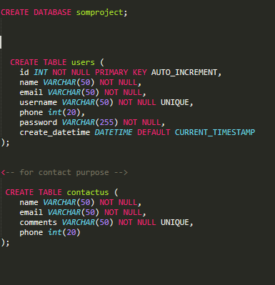

Step2: After creating the database the copy all the files to xampp-htdocs

Step3: Open browser and type localhost/(folder name)

(localhost/vcd/final) on this project.

Step4: After that it will direct you to the index page

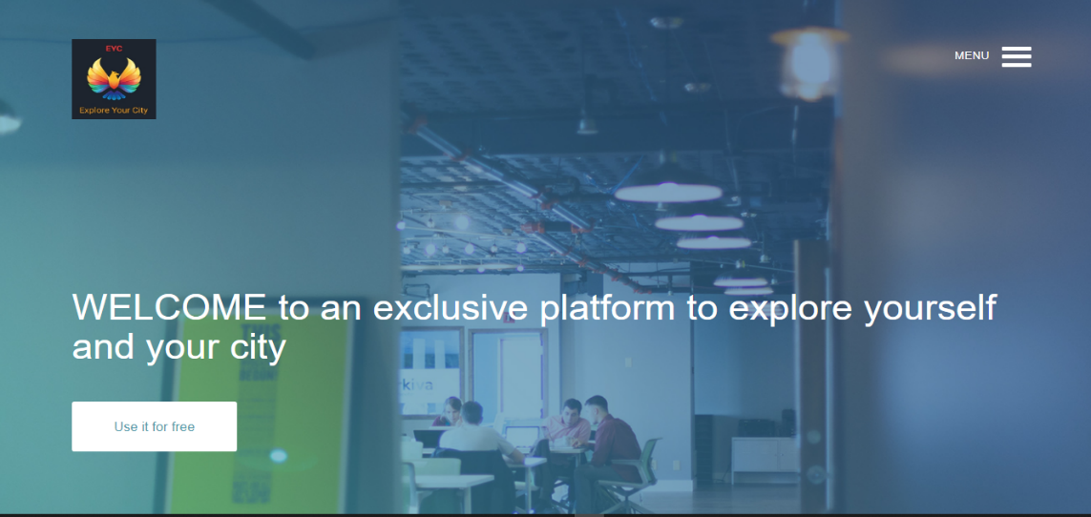

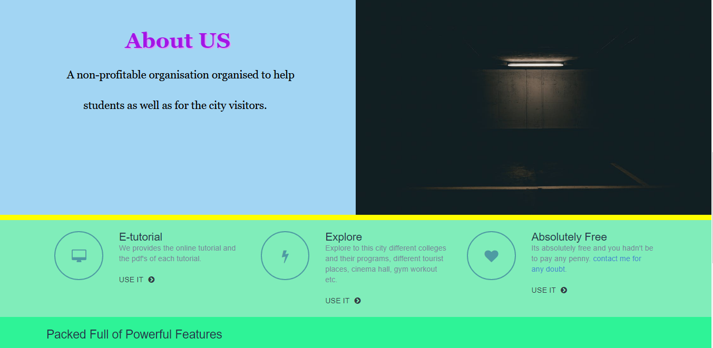

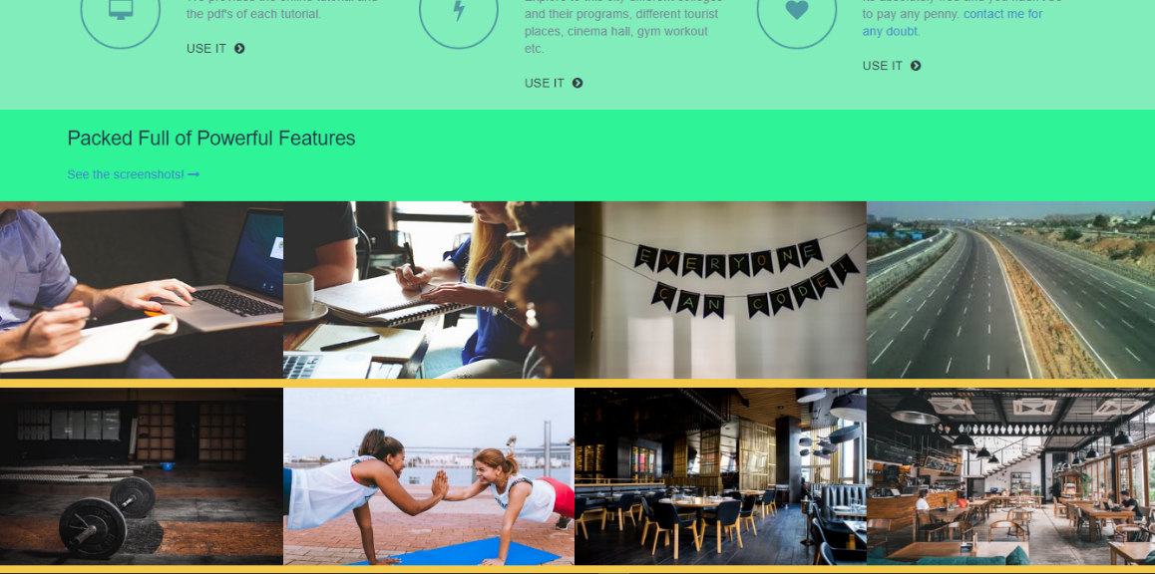

Step 5: Then explore the page then you want to move forward then click to the menu section in the right top corner of the page

Step 6: For new user register and for the existing users they have to login to move forward.

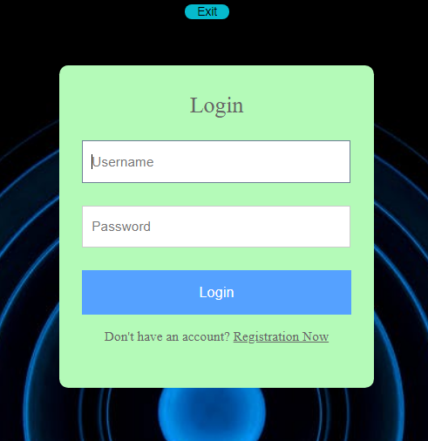

Step 7: Login for the existing users

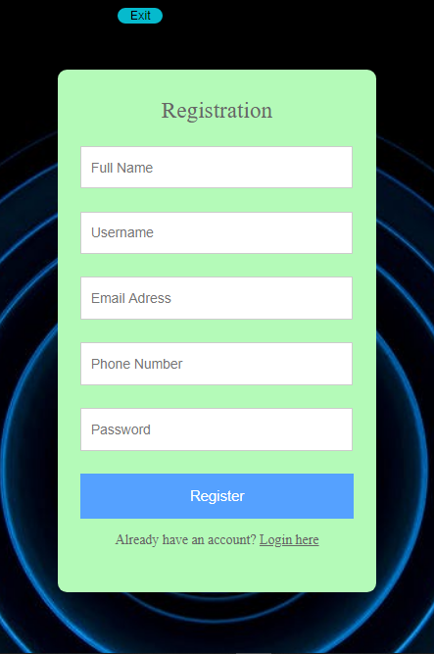

Step 8: Register for new users

Step 9: Then you will be directed to the dashboard where you have two paths i.e. the forward path to explore and the logout path if you have to get back to the index page.

Step 10: On clicking the explore button then you will be directed to the welcome page where you can access to different portal like the tutorial section, college section, gym section and the tour and travel section.

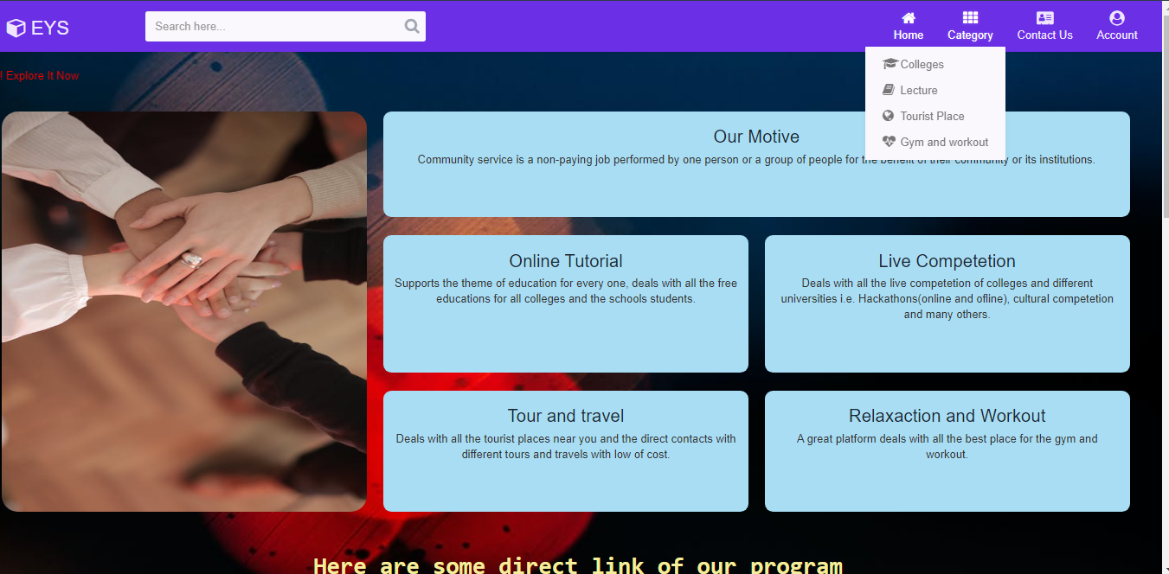

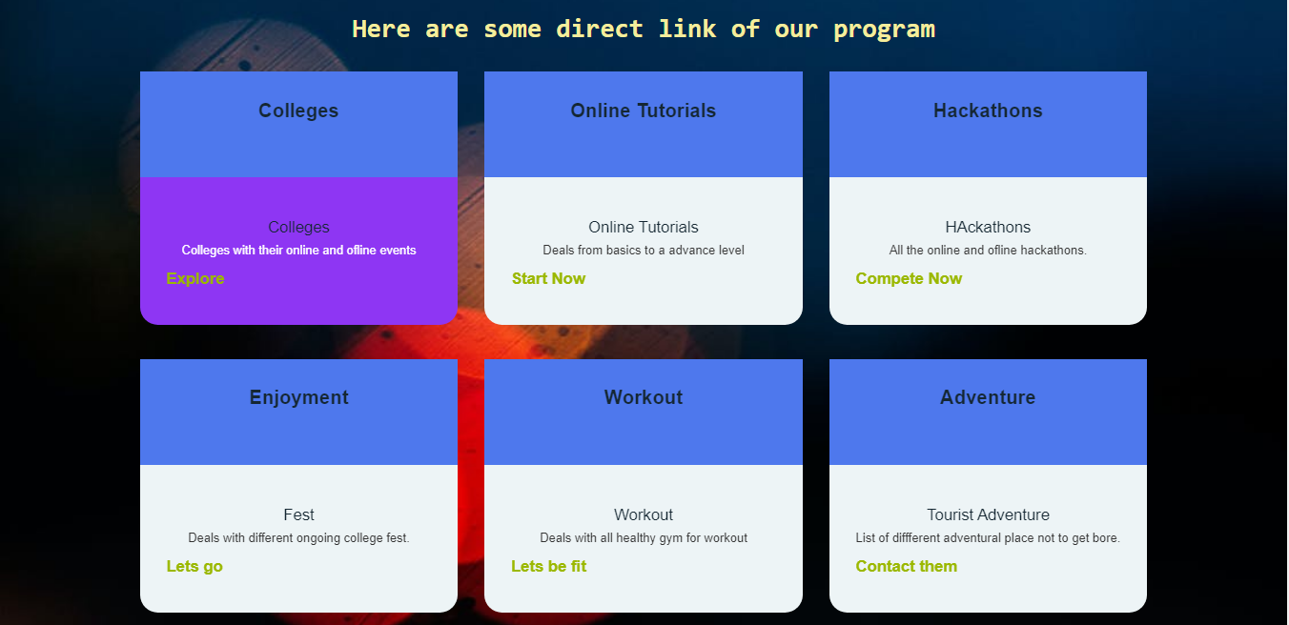

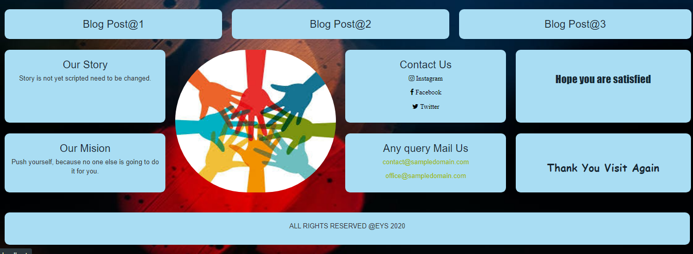

**College Section**

Here you will direct link to different college event near you.

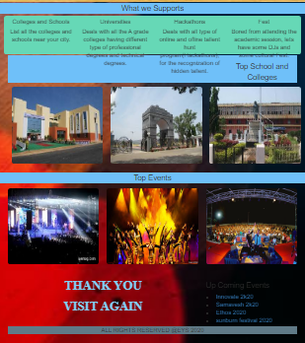

**Online Tutorial Section**

Here you will direct link to different section tutorial section which is totally free of cost

On clicking the cources you will directly link to different tutorial pages.

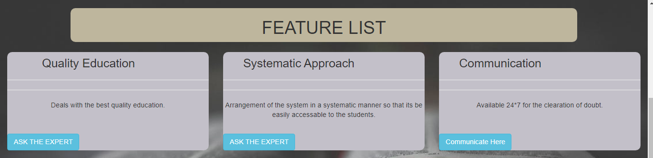

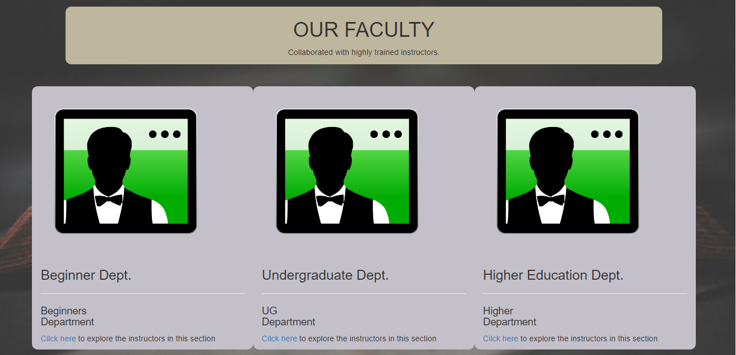

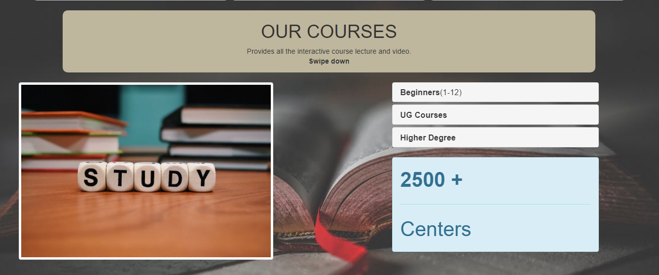

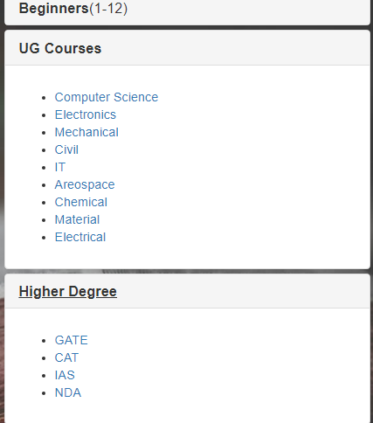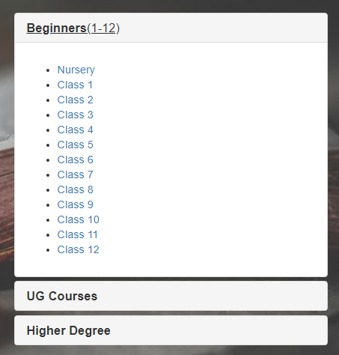

**Gym Section**

Here you will directly link to different gym expert for the fitness of the body.

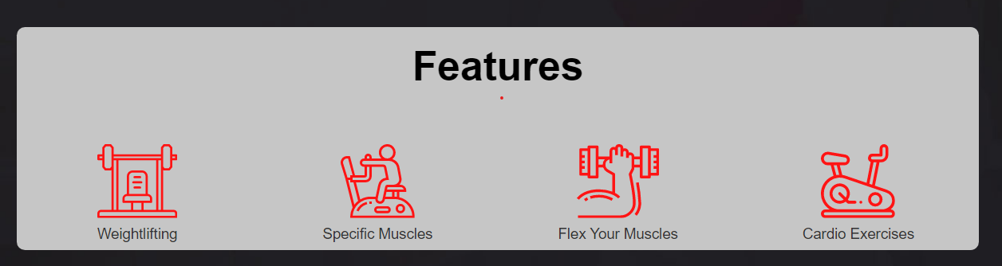

**Tourist Section**

Here you will directly link to different travel places near you and also different tours and travels agents for the foreign tour.

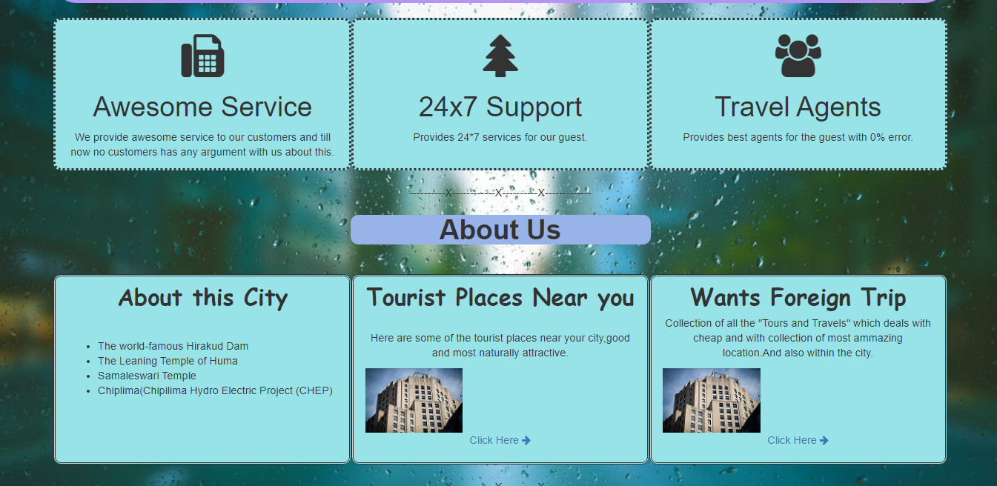

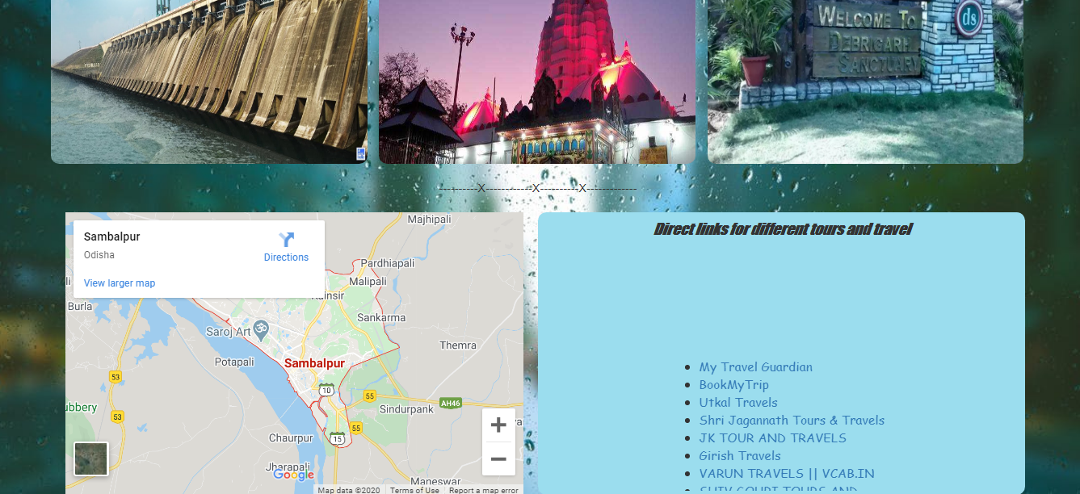

After exploring on clicking the logout button you will directly link to the login page and then on clicking exit button you will link to the index page.

**Conclusion**

Thus at the end we want to say that it’s totally free community development project where a person of a city can explore different portion of the city.